**Submission -7**

**1.Develop java program to do meaningful transaction using your DB.**

**MAIN METHOD:**

package _221047005;

import java.sql.Connection;

import java.sql.DriverManager;

import java.sql.PreparedStatement;

import java.sql.ResultSet;

import java.util.Scanner;

public class Jdbcmain {

static Connection connection;

public static void main(String[] args)throws Exception {

/*String connectionUrl = "jdbc:sqlserver://172.16.51.44;" +

"databaseName=221047005;integratedSecurity=false;user=Sadhana;password=sadhana#1";

connection = DriverManager.getConnection(connectionUrl);

String sql="create table prod1"+"(PID integer,Productname varchar(100),Productunitprice float,Quantities integer, PRIMARY KEY(PID))";

PreparedStatement preparedStatement=connection.prepareStatement(sql);

//Execute the query

int n=preparedStatement.executeUpdate();

if(n==1) {

System.out.println("table not created");

}

else {

System.out.println("table created");

}

preparedStatement.close();

connection.close();*/

Jdbcimpl p=new Jdbcimpl();

Scanner sc=new Scanner(System.in);

System.out.println("Enter your choice 1.insert 2.delete 3.display");

int n1=sc.nextInt();

if(n1==1) {

p.insertvalues();

}

else if(n1==2) {

p.deletevalues();

}

else if(n1==3) {

p.displayval();

}

}

}

**OPERTIONS:**

package _221047005;

import java.sql.Connection;

import java.sql.DriverManager;

import java.sql.PreparedStatement;

import java.sql.ResultSet;

import java.sql.SQLException;

import java.util.Scanner;

class Jdbcimpl {

static Connection connection;

void insertvalues() throws SQLException, ClassNotFoundException

{

Scanner sc=new Scanner(System.in);

String connectionUrl = "jdbc:sqlserver://172.16.51.44;" +

"databaseName=221047005;integratedSecurity=false;user=Sadhana;password=sadhana#1";

connection = DriverManager.getConnection(connectionUrl);

String sql="insert into prod1 values (?,?,?,?)";

PreparedStatement preparedStatement=connection.prepareStatement(sql);

System.out.println("Enter PID");

int pid=sc.nextInt();

preparedStatement.setInt(1, pid);

System.out.println("Enter Product name");

String pname=sc.next();

preparedStatement.setString(2,pname);

System.out.println("Enter Price");

float price=sc.nextFloat();

preparedStatement.setFloat(3,price);

System.out.println("Enter Quantity");

int quantity=sc.nextInt();

preparedStatement.setInt(4,quantity);

//Execute the query

int n=preparedStatement.executeUpdate();

if(n==1) {

System.out.println("record inserted");

}

else {

System.out.println("record not inserted");

}

//closing

preparedStatement.close();

connection.close();

}

void deletevalues() throws SQLException, ClassNotFoundException{

Scanner sc=new Scanner(System.in);

String connectionUrl = "jdbc:sqlserver://172.16.51.44;" +

"databaseName=221047005;integratedSecurity=false;user=Sadhana;password=sadhana#1";

connection = DriverManager.getConnection(connectionUrl);

String sql="Delete from prod1 where PID=?";

PreparedStatement preparedStatement=connection.prepareStatement(sql);

System.out.println("Enter PID to delete Product");

int delpid=sc.nextInt();

preparedStatement.setInt(1,delpid);

int n=preparedStatement.executeUpdate();

if(n==1) {

System.out.println("deleted");

}

else {

System.out.println("not deleted");

}

preparedStatement.close();

connection.close();

}

void displayval() throws SQLException, ClassNotFoundException {

Scanner sc=new Scanner(System.in);

String connectionUrl = "jdbc:sqlserver://172.16.51.44;" +

"databaseName=221047005;integratedSecurity=false;user=Sadhana;password=sadhana#1";

connection = DriverManager.getConnection(connectionUrl);

String sql="Select * from prod1";

PreparedStatement preparedStatement=connection.prepareStatement(sql);

ResultSet resultSet=preparedStatement.executeQuery();

while(resultSet.next()) {

System.out.println(resultSet.getInt("PID")+" "+resultSet.getString("Productname")+" "+resultSet.getFloat("Productunitprice")+" "+resultSet.getInt("Quantities"));

}

resultSet.close();

preparedStatement.close();

connection.close();

}

}

**OUTPUT:**

**1.Added a product**

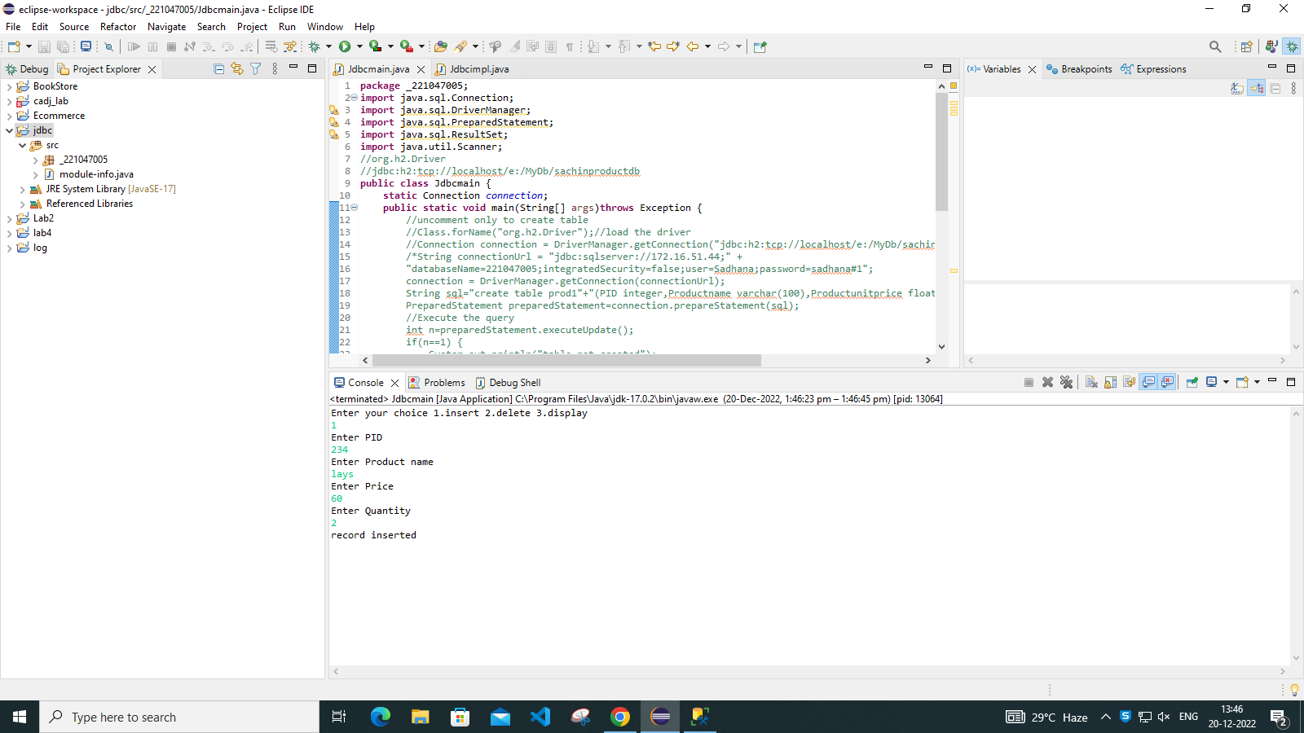

**Table create for the added product**

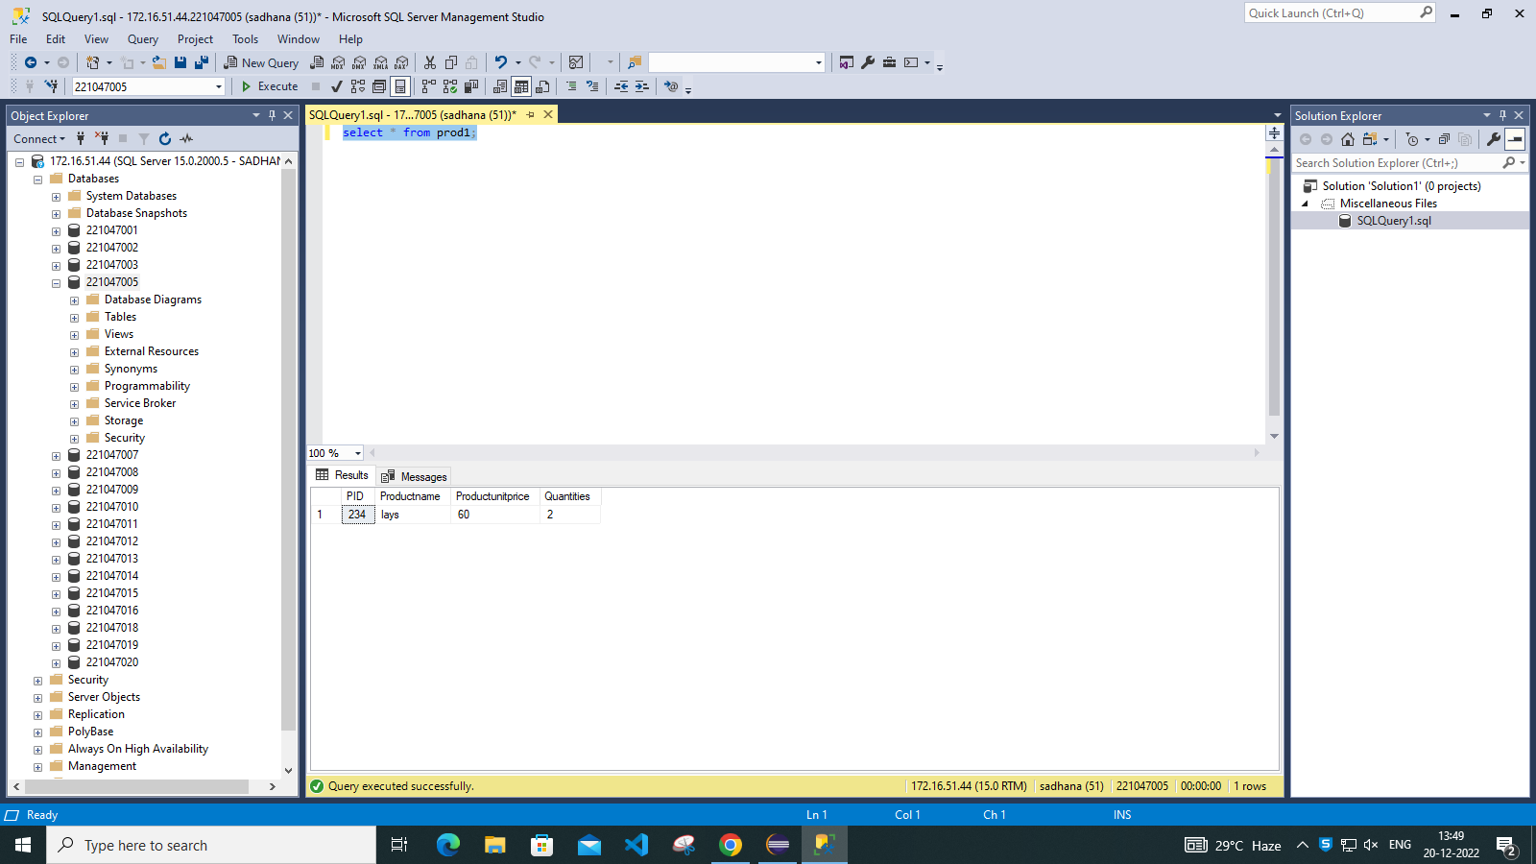

**2.Deleted a product**

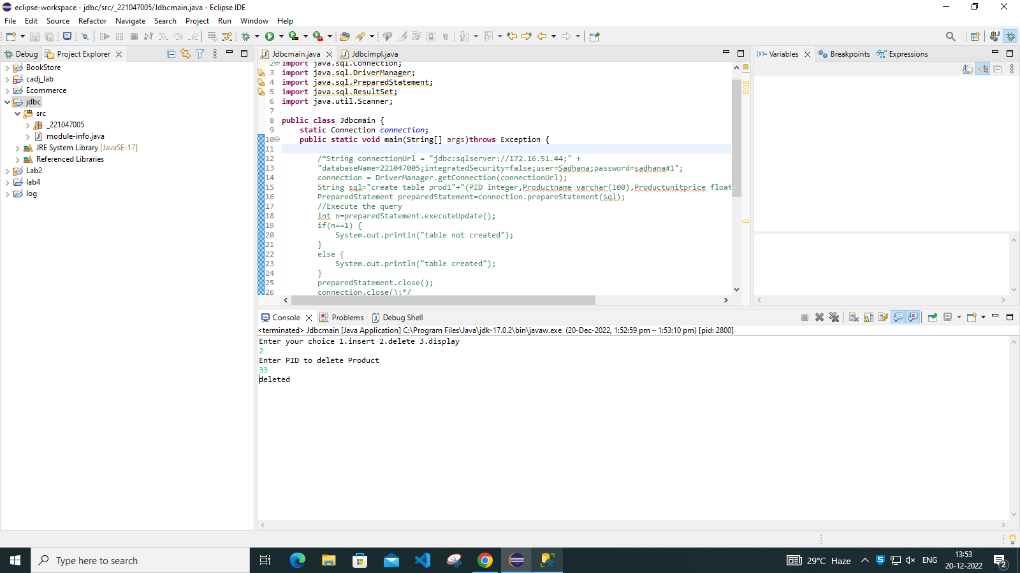

**Deleted a product in table**

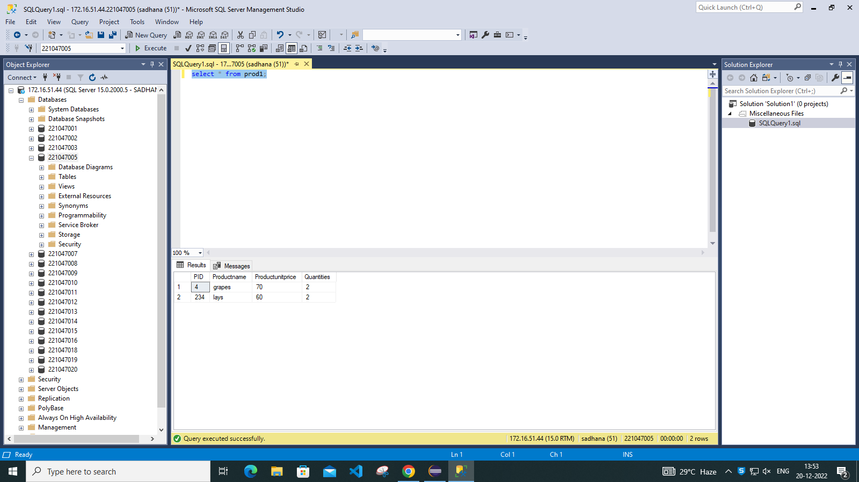

**3.Display product**

